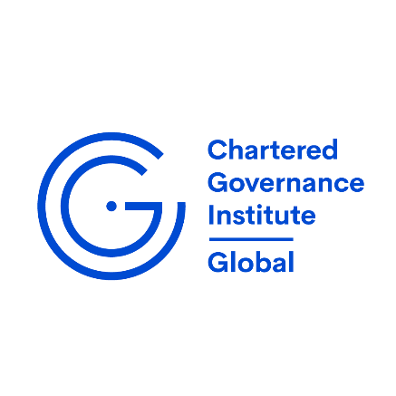

Minutes of the Annual General Meeting of Members of The Chartered Governance Institute (The Institute) held at 17.00 hrs. (local time) on Tuesday, 9 September 2025 at the Hub Wynyard, Level 11, 10 Carrington Street, Sydney, Australia and virtually via LUMI.

- Introduction
John Heaton, CGI Global President and Chair of the meeting welcomed those in attendance for joining the AGM in person and virtually through the LUMI platform.
- Quorum
The AGM quorum was met with the minimum of 20 Eligible members required under Byelaw 31.
- Business of the meeting
The President introduced the two other top table participants, Kerrie Waring, Director General and Cynthia Mora-Spencer, Institute Secretary. He also introduced other members of the CGI Global Council attending the meeting in person.
Questions were open for members to submit, and the President advised that they would be answered when the Q&A session was opened later in the meeting. If not, all questions could be answered today, they would be answered within 48 hours and answers posted on the CGI Global website.
The Chair reminded members attending that the notice of the AGM had been sent to members the week commencing 11 August 2025 and was posted on the website immediately after.
The Institute Secretary explained the procedure for voting on two resolutions put forward for approval at this AGM:
- To receive and consider the report of the Council on the business of the Institute for the year ended 30 June 2025.
- To receive comprehensive financial statements of the Institute for the year ended 30 June 2025.

- Report of the CGI Global President and CGI Global Council
The President reported on reported on significant strategic developments, including the appointment of Kerrie Waring as Director General in December 2024, following a rigorous recruitment process and also extended thanks to Tim Sheehy for nine years of distinguished service as Director General. The Institute’s vision and purpose were reaffirmed, with a continued focus on public policy advocacy and professional qualifications for Company Secretaries and Governance Professionals. Membership stood at over 28,000 across nine divisions, and a review of the qualifying programme was undertaken to ensure its ongoing relevance and quality including climate change and technological advances.
It was noted that the CGI Global Council had agreed four strategic priorities: modernising qualifications, raising awareness, expanding into new markets, and strengthening governance. A new Global Policy and Advocacy Committee had been established, and the CGI’s website was being enhanced to improve access to resources and showcase divisional thought leadership.

CGI’s internal governance had been strengthened through updated mandates and procedures, with a permanent Governance Committee to be established from September 2025.

The President reported a total year-end financial loss of £46,384, including an unexpected HMRC liability, and confirmed that Council has approved measures to rebuild reserves and ensure long-term sustainability.

In closing, the President expressed confidence in the Institute’s future and its ongoing leadership in governance. The President then handed over the meeting to the Director General, for her address.

Director’s General address
The Director General opened by expressing gratitude to Council members, former members, and the CGI Global team for their commitment and support in refreshing CGI’s strategic direction. Appreciation was extended to the former Director General and Divisional CEOs for their foundational work and ongoing efforts.

The current challenge of declining membership across professional organisations was highlighted and the vital role of governance professionals in today’s business environment was emphasised.

The four principal strategic priorities for CGI Global were highlighted. Firstly, the organisation would modernise its Qualifying Programme to maintain its status as the leading global governance qualification, including updates to competencies, membership categories, syllabus, assessment methods, and digital course delivery. Secondly, efforts would be made to raise awareness of the governance profession among employers and regulators, supported by the newly established Global Policy and Advocacy Committee, which would engage in international consultations and events. Thirdly, internal governance would be strengthened through the formation of new committees, enhanced nomination procedures, and an updated Council Skills Matrix to guide appointments and divisional selections. Finally, resource management would be addressed by maintaining financial stability through divisional fees, exploring new revenue streams, and investing in qualification modernisation and advocacy initiatives.

The remarks concluded with thanks to all contributors, especially those hosting the AGM and Council meetings.

- Questions
No questions were raised

- Resolutions
The vast majority of voting members approved all of the resolutions put forward at the AGM.
The following resolutions were voted on by way of a poll:

 | For | Against | Abstain
Resolution 1 | 181 | 1 | 1
Resolution 2 | 181 | 1 | 1

